Project Design Document

1. Design Intent
- We set out to create a very fun and lighthearted experience with this project, create a fun project with ourselves to test our limits as people who had never touched electronics before this module began, to being a cute pet for people to look at and get attached to.
- It’s meant to act almost like a first prototype for a robotic pet for a kid, complete with animations and music aiming to stimulate.

2. Inspiration & References
- Inspired by Rocky from Project Hail Mary, R2D2 from Star Wars, The Graduation Bear by Kanye West
- 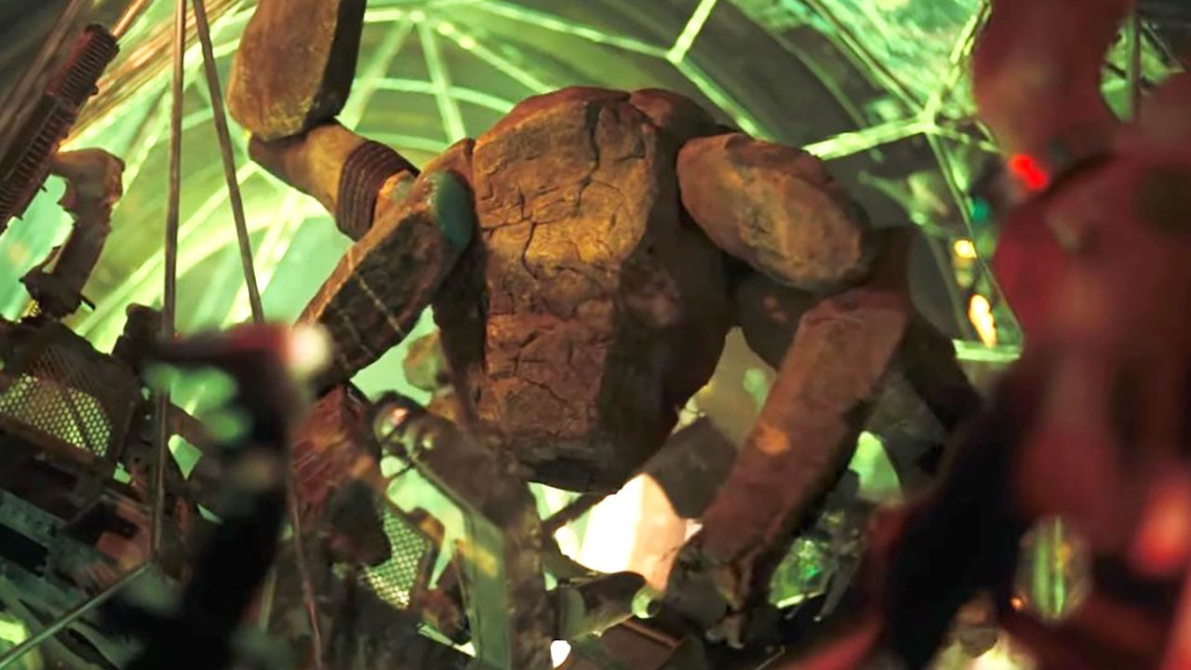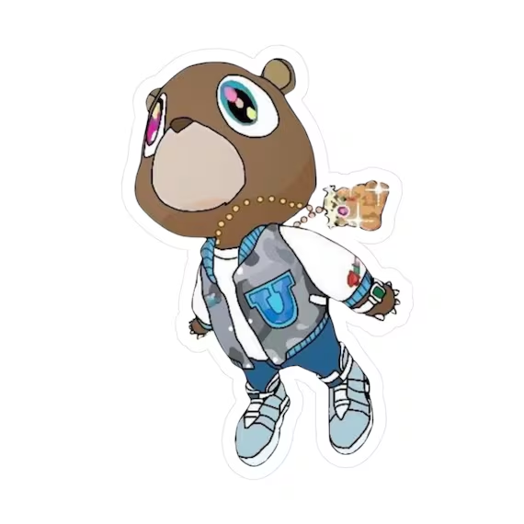

3. User Journey
Step-by-step experience of the user:
- A user walks by this robot, standing on its stage, with a tablet beside it explaining what it is, what is does.
- Intrigued, the user decides to flip the switch behind the bot’s head.
- Suddenly, it comes to life, with a fun robotic voice and an animation making it seem friendly, it introduces itself, YeezyBot.
- It goes through it’s routine, dances to a song, idles to a Mario Theme, and finally, it walks towards you, wanting to be your friend :)

4. Success Criteria
Define measurable success:
- Speaker and Animations startup in <1 second of each other
- User experience relies on the user only turning a switch on, and not having to interfere with any of the servo positions
- Animation goes through the entire 2:35 minute routine uninterrupted
- The robot doesn’t tip over or walk off its stage

5. System Overview
Yeezybot is an ESP32-based quadruped that performs a walking/dance routine with on-board OLED animation and audio playback. The ESP32 runs MicroPython and drives three peripheral subsystems . An I2C link (SCL=22, SDA=21, 400 kHz) talks to a PCA9685 16-channel PWM controller, which generates 50 Hz servo pulses for the eight leg servos — four hip joints and four knee joints arranged as a diagonal-trot gait with rear-biased back-lean to compensate for the front-heavy chassis. A dedicated SPI bus (SCK=18, MOSI=23, DC=2, RST=4, CS=5, 20 MHz) streams a 1,210-frame MONO_VLSB animation (⁠ comp4.bin ⁠) to a 128×64 SSD1309 OLED, with frame advances interleaved into the servo step loop so playback never stalls the walk. A DFPlayer Mini, driven over UART with its serial command protocol, plays the matching audio track from microSD in lockstep with the dance routine.

6. High-Level Block Diagram
👉 Visual diagram of system components and flow
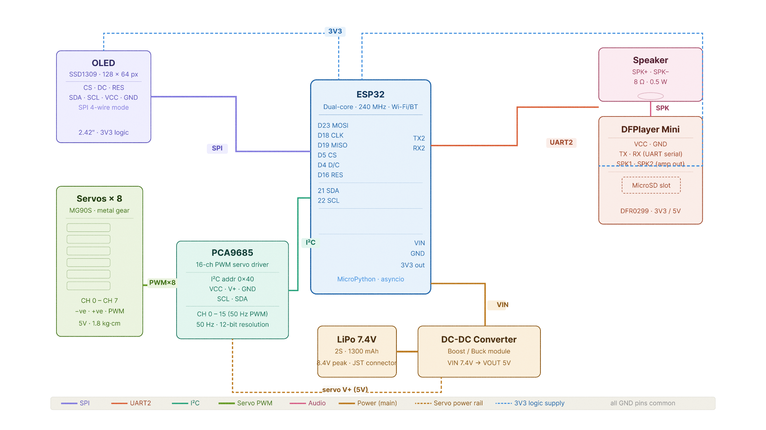

7. Input / Output Mapping
Input | Process | Output
7.4V power supply | Buck convertor | 5v power
Servo channels to pca9685 channels | Servo driver/i2c | Individual control over servos
esp32 | Pca9685 through SCL AND SDA | Control over channels on the driver
Micro SD Card | DF Player Mini | .mp3 files played over speaker
Imag sequences as bin files | SPI | OLED Display

8. Sketches & Concepts
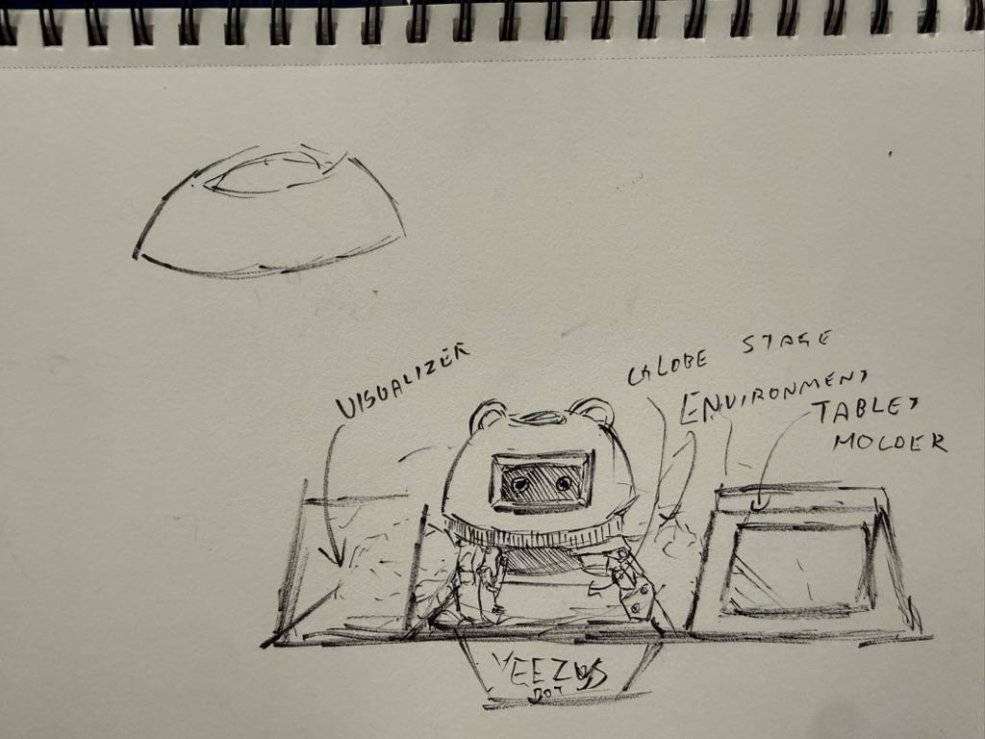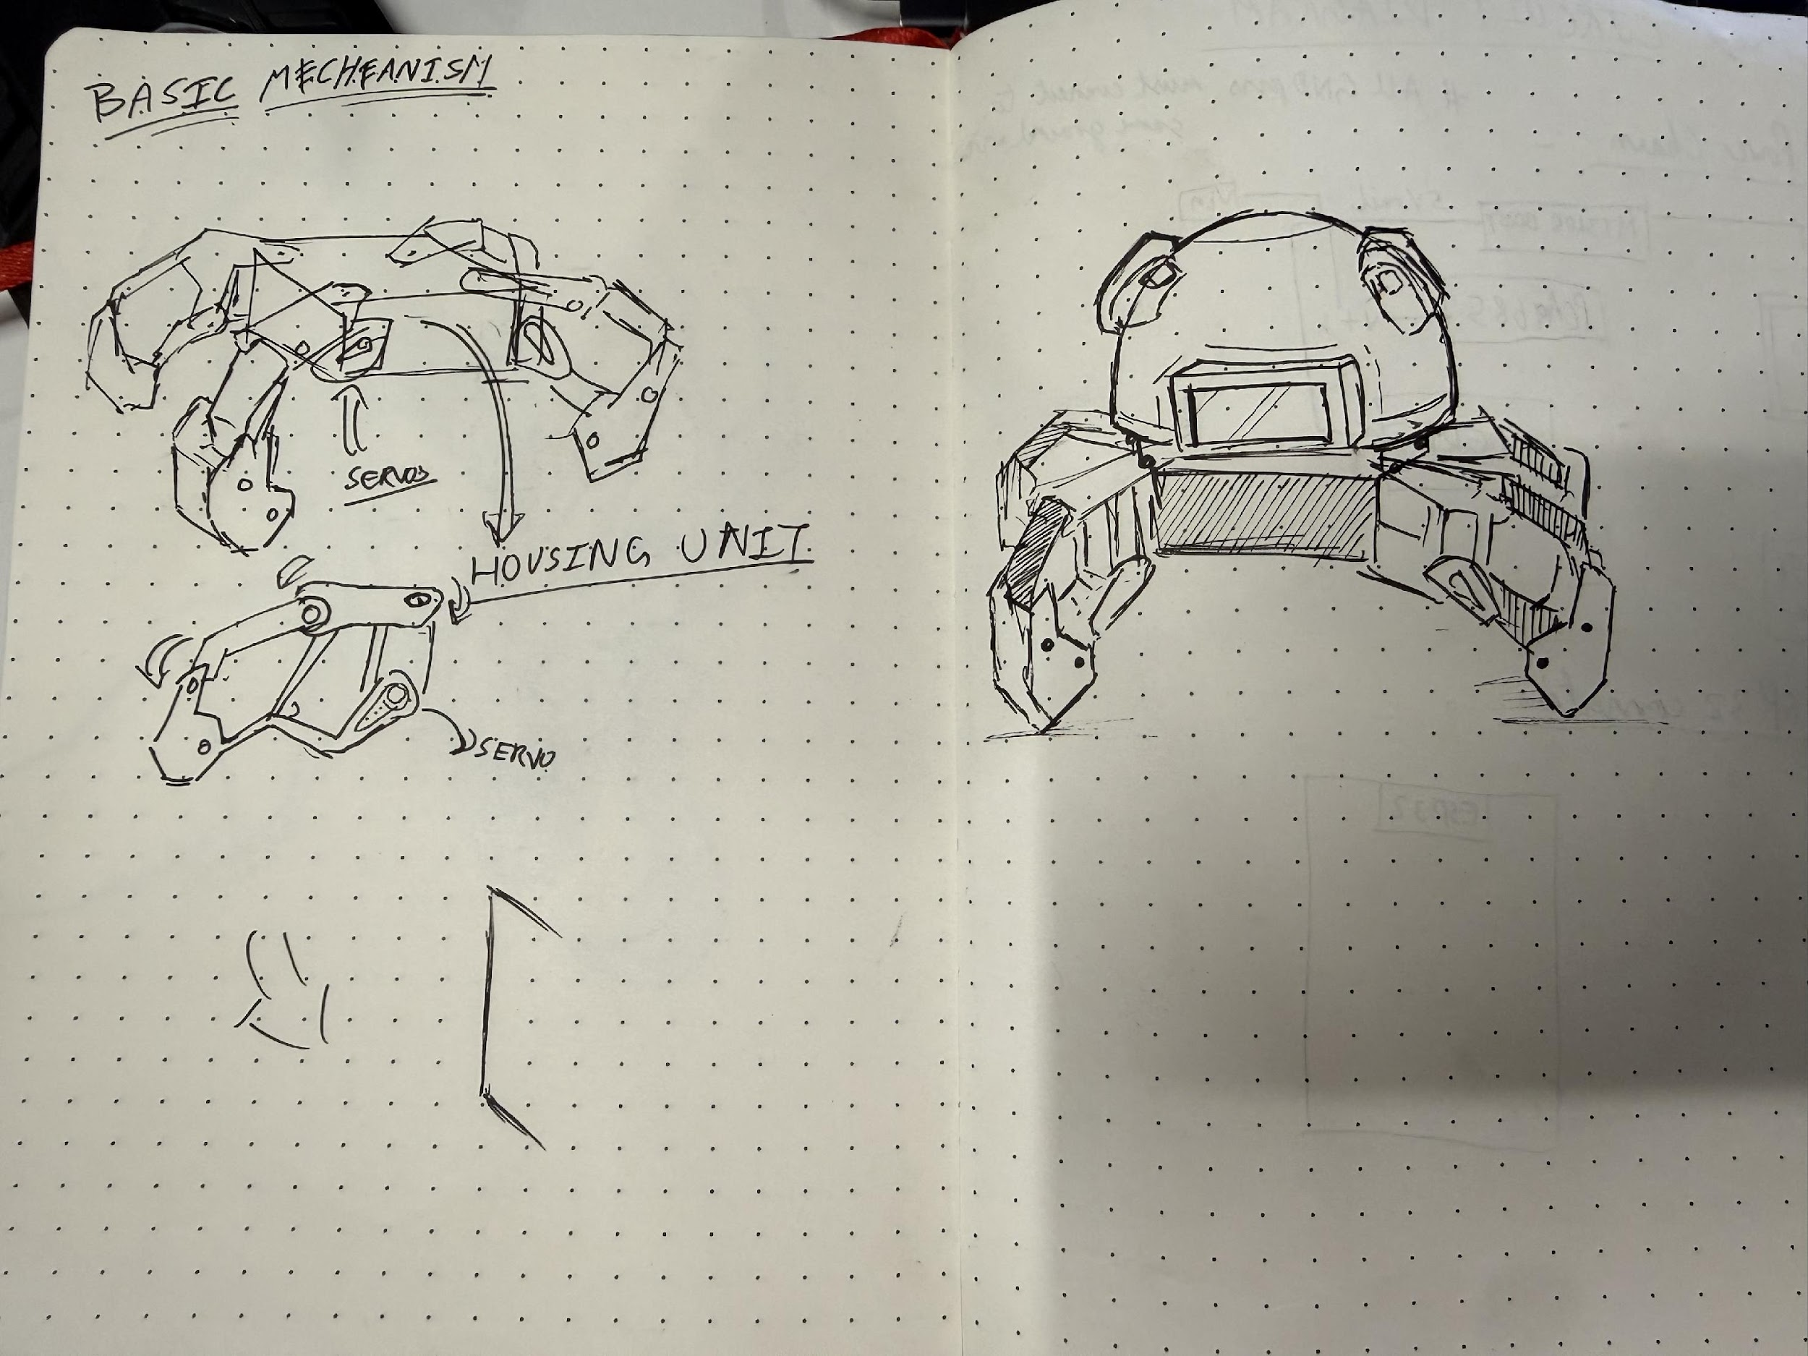

9. Final System Architecture (Labelled)
